Mount Litera Zee School Haridwar (2018-19)
Name: Class - Date:
Comprehension
1 Gone are the days when going to school was like any other ritual. Elders in the house would fix a specific day as shubh muhurat for going to school and puja would be performed before a child was put to a school then called Pathshala.The child would then seek the blessings of his elders and his teachers
( called gurus) to complete his education and to come out with flying colours. Guru , the teacher , would always treat his pupil like his own child and teach him till he was completely satisfied with his or her performance.
2 But it seems now that over a period of time the whole concept of education has changed. Now getting a child into a school is a billion dollar question and a real nightmare experience for the parents. The moment a toddler starts spreading his wings , the parents start worrying about his admission , which school they should send him to , or which school can they afford. They are even ready to spend more than their pocket allows for after all it is the matter of future of their child. The poor child does not even know how to talk properly.
3 Our public schools are always in the limelight with the onset of the admission season. They are set with their colourful advertisements for admission to various classes. After all the admission procedures are over , one would expect a call letter. The moment a call letter is received , mothers have a tough time in making their small children sit and teach them to remember certain things which would open the door for their future ( by getting admitted into a particular school). The poor kid without knowing anything has to listen to his mother so that she could make him scribble a few things on paper. They have to go through this exercise to make a name.

On the basis of the reading of the passage answer the following questions in brief:
a) Why are public schools always in the limelight?
b) With reference to the above passage how has the concept of education changed over a period of time?
c) How do public schools lure the prospective parents?
d) Why are the toddler's parents under pressure?

Answer the following questions as brief as possible:
a) Find a word from the passage similar in meaning to 'custom , tradition'.
b) Pick out word / words which mean the same as ' do well'.
c) 'Gone are the days'. Explain the meaning with reference to the passage.
d) Find a word from the passage opposite in meaning to 'delightful'.

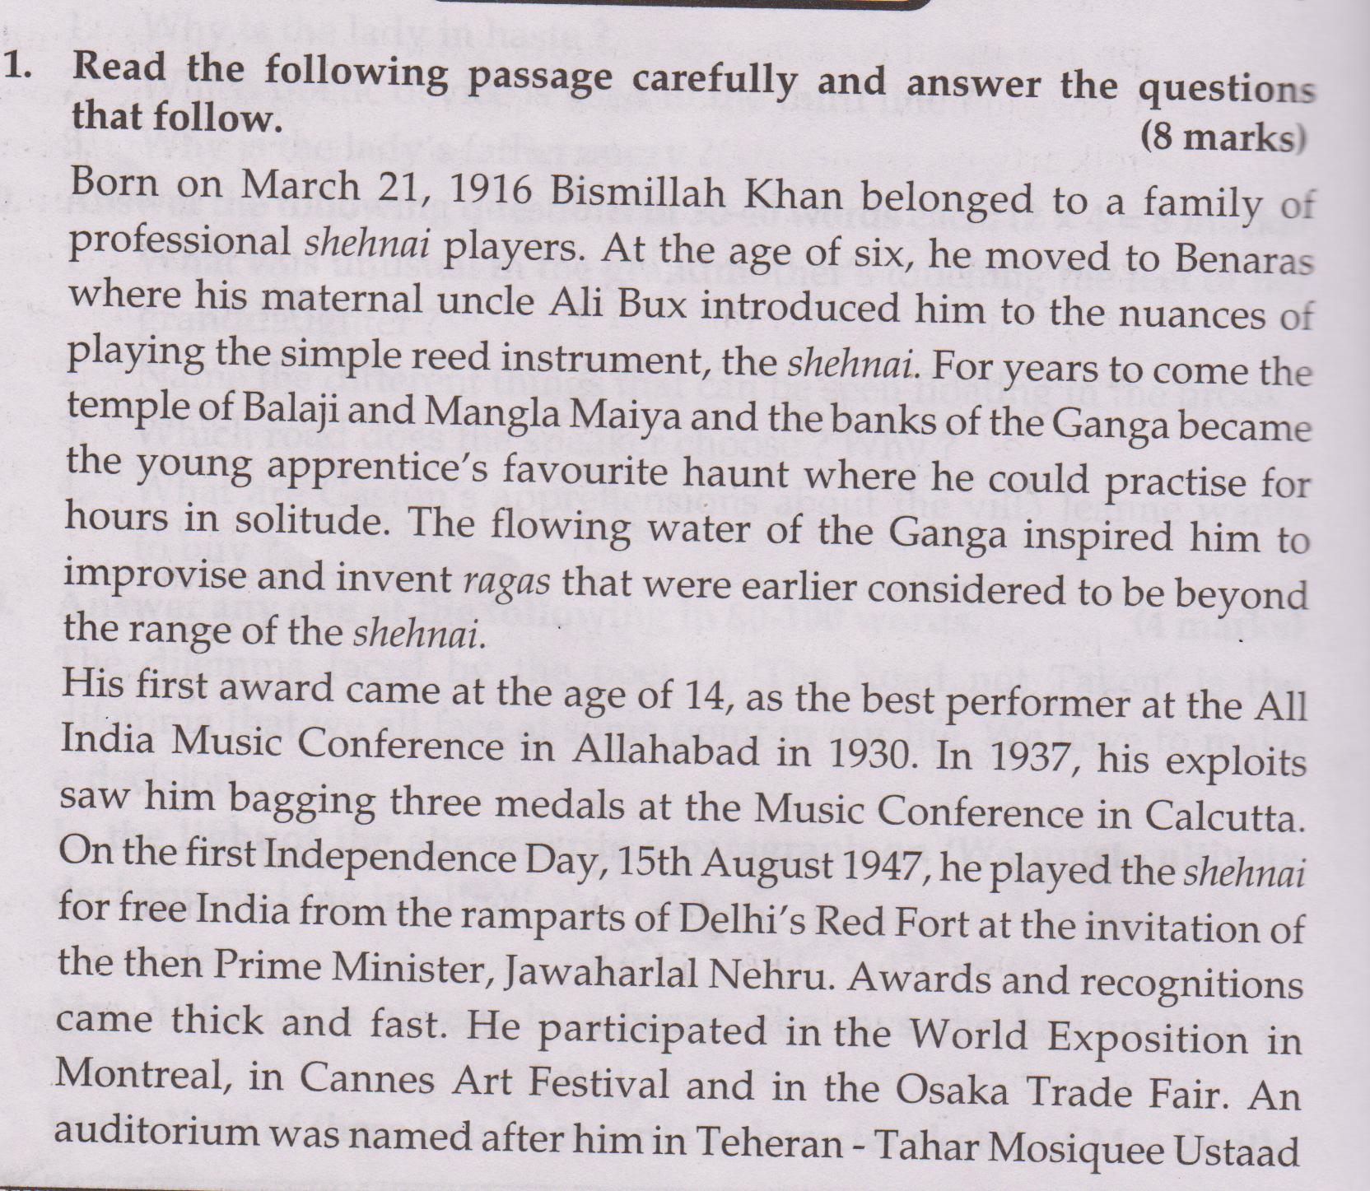
Bismillah Khan. The World Music Institute celebrated his 80th birthday in New York.
1. Where was Bismillah Khan born?
2. Which family did he belong to?
3. Who introduced him to the shehnai?
4. What did he need for daily practice?
5. What experiments did he make with the shehnai?
6. When was he awarded for the first time?
7. How was he honoured in Teheran?
8. Who invited him to perform at the Red Fort on 15th August,1947?

